SPARK STREAMING
Start a socket server and send your CSV lines and output is generating with batch intervals.

--> Step 1. Create a socket server (runs in background thread)
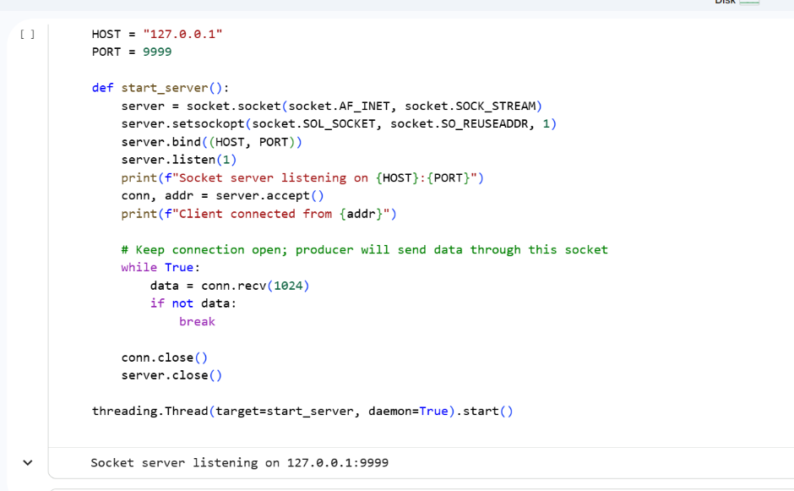
Step 2. Start a producer that streams CSV lines to the socket
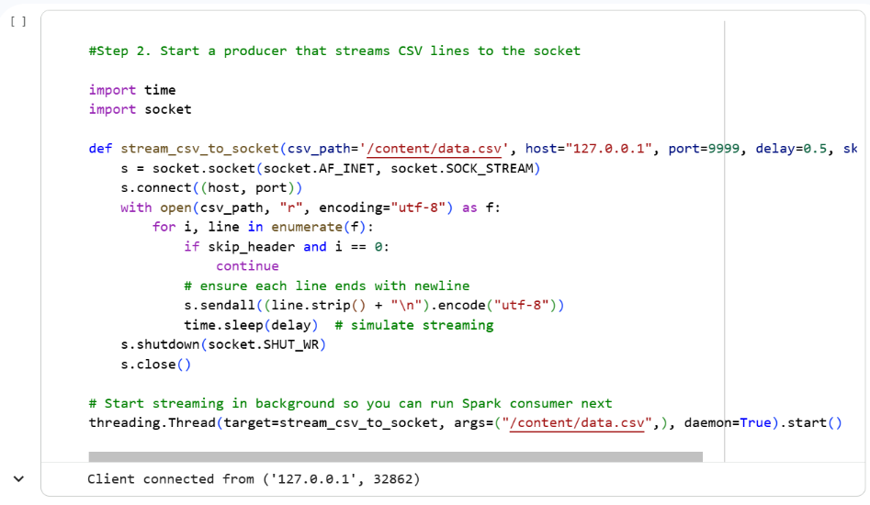
Step 3. Read from Socket Stream
Step 4. Define the Streaming Context
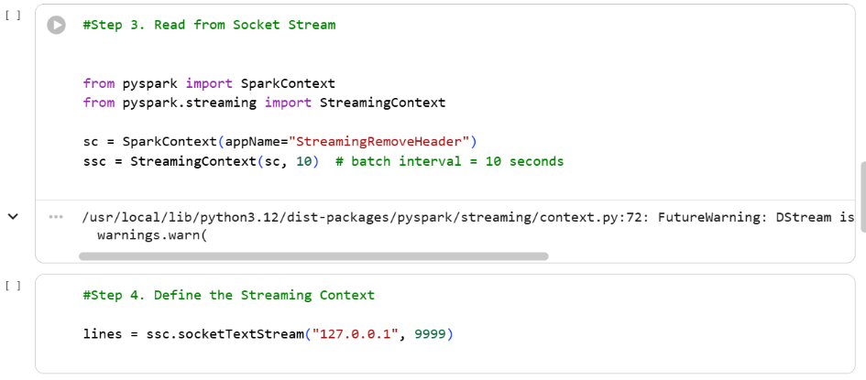

Step 5. Filter Out the Header

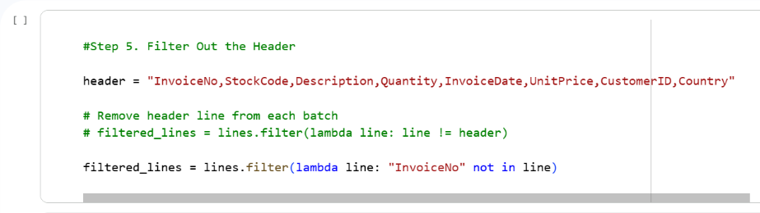

Step 6. Parse the Remaining Data
Step 7. Aggregate by CustomerID
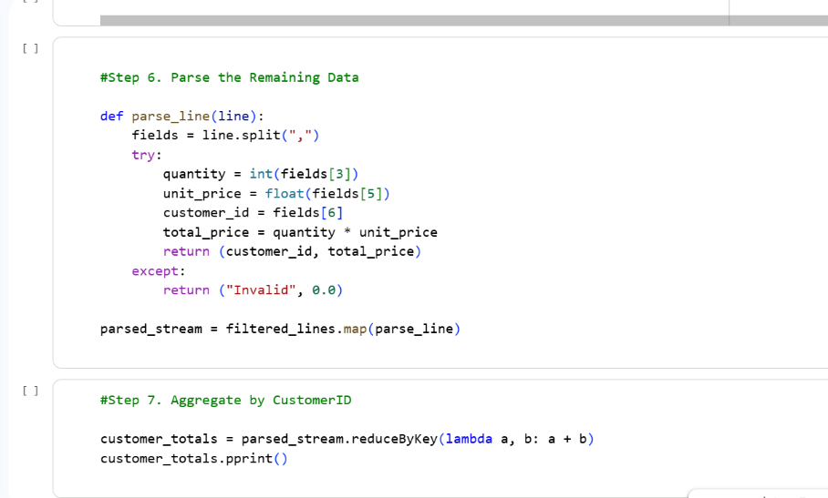

Step 8. Start Streaming

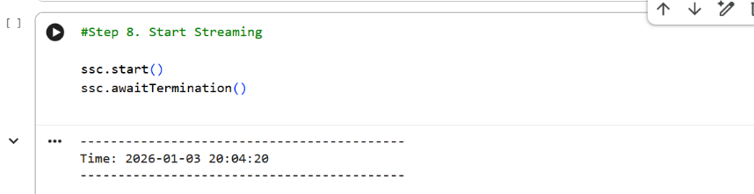
OUTPUT:
